Chapter available in book (below):

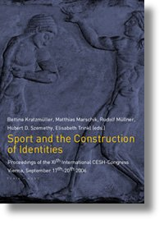
The Proceedings of the Vienna Congress were presented in the XIIth Cesh Congress in Lorient in 2007.
Bettina Kratzmόller, Matthias Marschik, Rudolf Mόllner, Hubert D. Szemethy, Elisabeth Trinkl (Hrsg.)
Sport and the Construction of Identities / Sport und Identitδtskonstruktion
Proceedings of the XIth International CESH-Congress, Vienna, September 17th-20th 2006
Wien 2007
938 S. , EUR 32,-
ISBN: 978-3-85132-494-5
Verlag: Turia + Kant
http://www.turia.at/titel/cesh.

http://www.univie.ac.at/cesh2006/proceed/proceed.htm

11th International CESH Congress 2006: Vienna, Austria[edit]
- Sport and the construction of identities = Sport und Identitätskonstruktion: Proceedings of the XIth International CESH-Congress: Viena, September 17–20, 2006. Edited by Bettina Kratzmüller, Matthias Marschik & Rudolf Müllner. Wien: Turia + Kant 2007. ISBN 978-3-85132-494-5
http://www.turia.at/titel/cesh.html

