

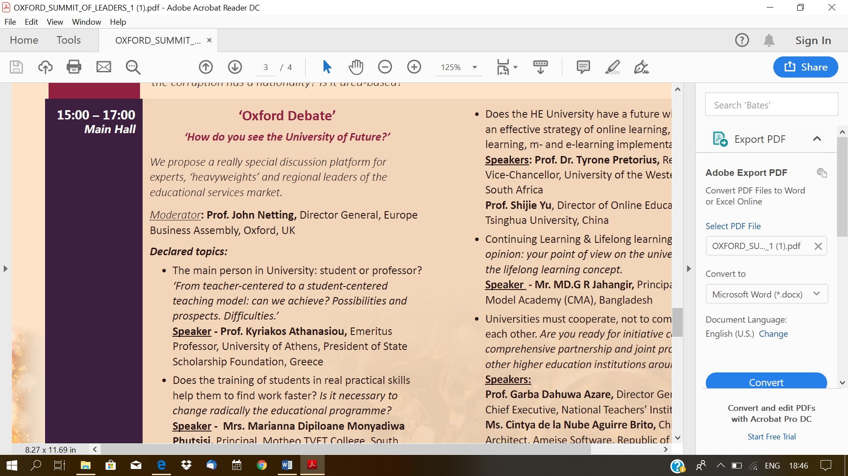

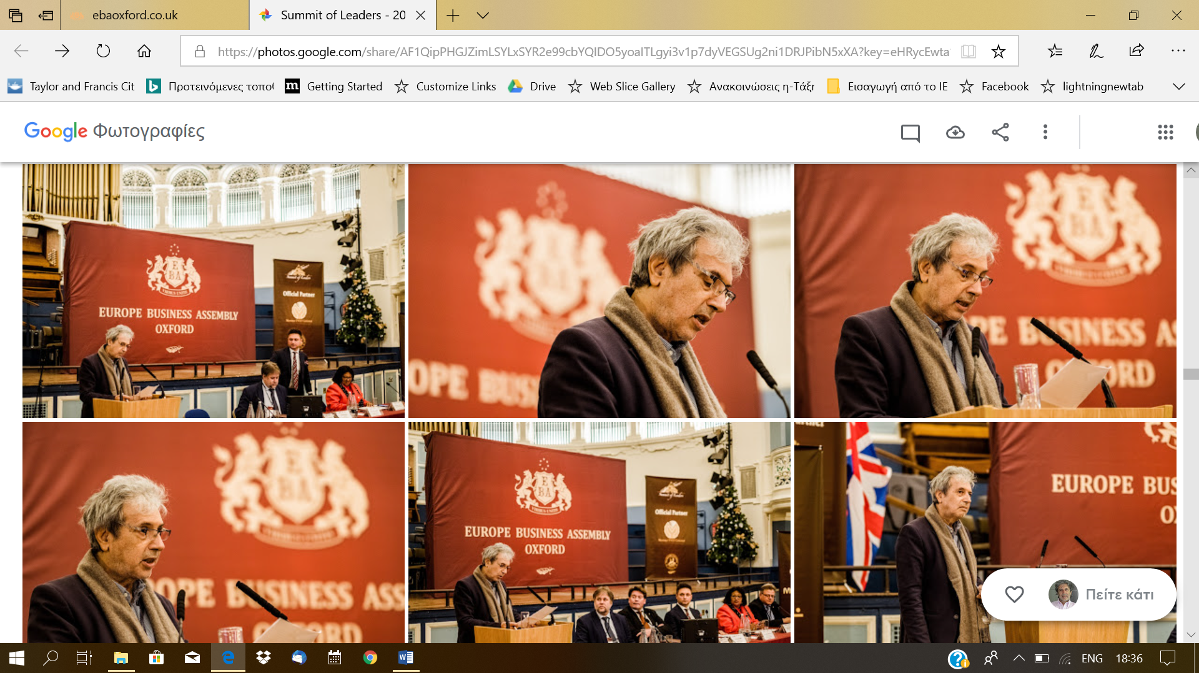

**From teacher-centered to a student-centered teaching model: shall we be successful?**

**Kyriacos Athanasiou, em. Professor, The Natl. and Kapodestrian University of Athens. President of the National Scholarship Foundation, 41, Ethnikis Antistaseos Ave, PO Box 14234,  Nea Ionia, Athens, GR.** [kathanasiou@iky.gr](mailto:kathanasiou@iky.gr)

**Student-centered learning**, also known as **learner-centered education**, broadly encompasses methods of [teaching](https://en.wikipedia.org/wiki/Teaching) that shift the focus of instruction from the [teacher](https://en.wikipedia.org/wiki/Teacher) to the [student](https://en.wikipedia.org/wiki/Student). It, also, focuses on skills and practices that enable [lifelong learning](https://en.wikipedia.org/wiki/Lifelong_learning) and independent problem-solving.

For many years the teacher, the professor, have been considered the center of teaching, the transmitters of knowledge, and the students, as empty vessels, were supposed to accept knowledge passively.

It seems after all, that we are entering a new era, where following the introduction of these approaches into the middle school system, the time has come, that they make their entrance into the Higher Education systems. As for the question on how we did get to this point, it is not very far from reality, if we say that two major milestones in the history of teaching and learning exist:

1. The introduction of the Idea of inquiry by John Dewey (1910). And,
2. The rise and domination of Constructivism in education for the last two decades, in the turn of the last century.

* John Dewey seems to be the first to introduce the idea of Inquiry as “an act or an instance of seeking for truth, information, or knowledge; or a question or query”.  Put it in other words, he was suggesting that students might be transformed to minor scientists. In other words, the movement of teaching by Inquiry was a movement that introduced the scientific method to the school class. Here we have the seeds of a big revolution: the transfer of the center of gravity from the teacher to the student.
* As for the Constructivism movement in education, I recall that is a movement that considers the preexisting knowledge of students as the greatest tool of teaching and learning. So, knowledge acquisition is considered now-on as a reconstruction or construction-upon and not as a transmission of knowledge. The student is, now-on, the object and at the same time, the subject of knowledge acquisition. The whole procedure is student centered. And, of course, the bibliography on students’ ideas on various areas of Science, is very rich (Duit, 2009).

Let me add two more historical points that complete the puzzle: First, *The project method:* It’s major contribution seems to be the fact that Students are not only the constructors of their knowledge, but have the right to chose even the themes and the domains of their learning. While “Problem Solving” method that was developed in the Medical School of Hamilton-Ontario seems to be one of the first attempts to introduce all these schemes and ideas in the Higher Education system, as well.

Going back to the time of John Dewey, it seems, that the outcome of all these ideas and movements associated with the first period of the prevalence of Inquiry, constituded, among others, some attempts to make transformations in the education system of USA and UK: e.g. the creation in 1959 of the “*Biological Science Curriculum Study*”, a committee which under the chair of Joseph Schwab put forward proposals to improve the curriculum and teaching of biology in U.S.. A committee that was responsible for the release of the *“Biology Teachers Handbook”* that introduced the first“*Invitations for Enquiry*”. Similarly, in the field of Physics it made their appearance *The Harvard Project* in US, while in U.K. *The Nuffield Science Teaching Project* was born, that made similar efforts of introducing some of these student centered practices in the Education System of UK.

In recent years, and after three decades of total prevalence of constructivism in Science teaching, there is a strong tendency, nowadays, of a pronounced shift, again, towards inquiry. Of course, the new perspective that is trying to put the Inquiry at the heart of teaching, once more, is not on an autonomous movement, but one that is strongly suggesting for the integration of the whole tradition of constructivism with Inquiry as a joint process aiming to *Conceptual Change*.

In summary, it seems that the course of things in Science teaching have been as it follows (Lord, & Orkwiszewski, Τ. (2006):

Inquiry Constructivism Constructivist Inquiry

### When preparing this speech, I was thinking to present some pros- and cons- of the approach. But the more I thought about, the more I came to entitle this part as,

“*Student centered teaching” as a “monodrom” i.e. as a one way procedure.*

I mentioned earlier that in the new meta-constructivist era, we are not talking anymore about the acquisition or transferring of knowledge but about a "conceptual change". i.e. our goal should be the acquisition of substantial knowledge or as it was put-down by Ausubel (1962), the *meaningful learning*, in distinction to the *rote* one.

Of course, traditional ways of teaching helped to move humanity forward and built civilizations. And is still of precious value. After all, most of us that are present here in this room or temple of knowledge have been grown up by such teaching procedures.

But things have changed drastically. Today’s young men and women live in a new reality, of New Techs, multimedia, social media, globalization, and so on.

It seems that the use of new, fast growing New Techs has produced students who need instant feedback and participation. Today's students are hard to sit and listen to a lecture or a laboratory work, passively, without actively participating. They deserve active learning procedures that include decision making actions, to participate in group learning actions, in projects, etc. all the actions that constitute contemporary student centered teaching and learning.

But most of all, students need to learn how to sieve and evaluate the information. How to distinguish the scientific truth and scientific products from gossip and misinformation.

It seems that we live in a new era where the development of new technologies, social media, and a situation of globalization have favored the faster proliferation of misinformation compared to accurate information itself. The wrong knowledge to sound knowledge. The new instruments are conducive to manipulation of information and its transformation into Para- information.

There are numerous examples of such instances:

We experienced recently a situation where the notion that Portuguese, Italians or Irish, Greeks and Spaniards we are all PIGS. The idea travelled and dominated so fast. And in a short time we experienced the reverse path. Within three years we became PIGS and good people again. We Greeks, in one year we were declared as the kings of laziness and, later-on, we were recognized as the people who work more than everyone in Europe, again.

How about the impact of *Economism*? I am referring to the idea that everything is economy. It has replaced the idea of a United Europe that was built upon humanitarian values. I invite you to think about on how the idea that everything is monetarism prevailed so fast in recent years in the Diocese of enlightenment and cultural values i.e. Europe. We have to wonder about how the ideology of racism and fascism at such large extents overtook in so short time throughout the old continent. How we have built walls so fast on the continent of Democracy and solidarity? All together, I believe that what we call Education has to become Literate, *Paedia* again. Let me have the illusion that student centered teaching strategies might have such effects. That through active learning, people will learn to sieve knowledge again. That they will become able again to take back the ability to throw away mental garbage.

In the third part of this communication I wish to highlight some of the issues or topics that are relevant to these teaching interventions. Higher education professors when they start to apply student-cantered teaching strategies in their class, apart from being specialists in their field they need to have some other skills:

First of all, they must be well familiar with all the pedagogical strategies under discussion. And they must be ready to face the reality that these strategies are harder to be applied, compared to the traditional ways of teaching. They need the acquirement of special skills and abilities that are obtained by hard training and instruction.

And secondly, the University teacher has to be well educated in the Epistemology, History and Philosophy of Science, as well.

In one of my graduate science classes we asked the students to write an essay that was entitled as follows:

*“By the use of Inquiry, formulate a lesson plan about the evolution of the concept of “Power” or the concept of “Gene”, starting with Aristotle, and reaching the contemporary period”.*

If the students were familiar with Epistemology and Philosophy of Science, they were also, familiar with the ideas of Thomas Kuhn, who had made several notable claims concerning the progress of [scientific knowledge](https://en.wikipedia.org/wiki/Scientific_knowledge): among others, he was claiming that the scientific fields undergo periodic "*paradigm shifts*" rather than solely progressing in a linear and continuous way. And that these paradigm shifts open up new approaches to understanding what scientists would never have considered valid before. Kuhn also argues that rival paradigms are [*incommensurable*](https://en.wikipedia.org/wiki/Commensurability_(philosophy_of_science)). i.e., it is not possible to understand one paradigm through the conceptual framework and terminology of another rival paradigm.

Thus, according to Kuhn, it is impossible for concepts, like the one of Power in Physics, to be considered in evolutionary terms and to be seen as successive from one Paradigm to the other, since concepts in different paradigms are incommensurable. The concept of power studied within the framework of the Aristotelian paradigm is inconceivable through the lenses of the Paradigm of Newton. And that of Newton’s is inconceivable to the Paradigm of Einstein. Because different Paradigms are [incommensurable](https://en.wikipedia.org/wiki/Commensurability_(philosophy_of_science)) and the language of one is not understandable by the other.

On the other extreme lies Biology as a separate science, where only one revolution exists: the shift from the Aristotelian Paradigm to the Darwinian one. If this is the case, and since the concept of gene, was introduced within the Darwinian paradigm, it is not paradoxical at all, for someone, to make comparisons between the concept under discussion, as it was conceived by Mendel, by Watson and Crick, by Luria and Delbrück, and by scientists in the contemporary era. For example, Gericke and Hagberg (2007) have defined five different historical models of gene function: the Mendelian one, the classical model, the biochemical-classical model, the neoclassical model and the modern one.

The point to be made is that the challenges to the University teacher who wishes to introduce some of these new student-centered teaching procedures in her University class, are several and rather hard to be handled: Teachers have to be specialists in their scientific field, they must know well most of the educational practices, and at the same time, they ought be aware of many of the Epistemological, Philosophical and Historical aspects of the chapter, theme or topic under presentation.

But, nevertheless, the attempt is definitely, worthwhile.

**Reference**

Dewey, J. (1910). Science as subject-matter and as method. *Science*, *31,* 121–127.

Schwab, J., Supervisor. (1963). *Biology Teachers’ Handbook*. John Wiley and Sons, Inc., New York and London.

Holton, G. (1969). [Harvard Project Physics: a report on its aims and current status](http://adsabs.harvard.edu/abs/1969PhyEd...4...19H). *Physics Education*, Volume 4, Issue 1, pp. 19–25.

Ausubel, D.P. (1963). *The psychology of meaningful verbal learning*. New York: Grune and Stratton.

Lord, T.R. & Orkwiszewski, Τ. (2006). Moving from didactic to Inquiry-Based Instruction in a science laboratory. *The* *American Biol. Teacher*, *68*, 342-345.

Kagan, S. (1989). *Cooperative Learning*. *San Juan Capistrano*, CA: Resource Teachers.

Duit, R. (2009). *Students’ and Teachers’ Conceptions and Science Education*. <http://www.ipn.uni-kiel.de/aktuell/stcse/>

Gericke, N.M. & Hagberg, M. (2007). Definition of historical models of gene… *Sci. & Educ.* *16*, 849–881.

Kuhn, Thomas (1962). [*The Structure of Scientific Revolutions*](http://projektintegracija.pravo.hr/_download/repository/Kuhn_Structure_of_Scientific_Revolutions.pdf) . Chicago, IL: The University of Chicago Press.